**610/4**

**ART**

**STUDY OF ART**

**Paper 4**

**Jul/Aug 2016**

2 hours

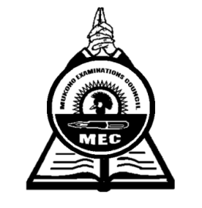

**MUKONO EXAMINATIONS COUNCIL**

**Uganda Certificate of Education**

ART STUDIO TECHNOLOGY

Paper 4

2 hours

**INSTRUCTIONS TO CANDIDATES**

*This paper contains***ten***questions.*

*Answer* ***all*** *the ten questions.*

*Drawings and diagrams should be used where necessary.*

1. a) Define the term Art  ***(02marks)***

b) Why is it important in formal education? ***(04marks)***

c) Explain problems faced by Art education in Uganda today. ***(04marks)***

1. Explain how following elements and Principles apply in Art and Design;

a) Shape ***(02marks)***

b) Texture ***(02marks)***

c) Colour ***(02marks)***

d) Proportion ***(02marks)***

e) Balance ***(02marks)***

1. a) Define the term casting ***(03 marks)***

b) How is clay an important material in Art and Design? ***(03 marks)***

4. a) Define the term Collage. ***(01 mark)***

b) Describe the process of producing a mask  ***(04marks)***

5. a) Define the term batik ***(01mark)***

b) Explain why is it advisable to use hot wax in Batik ***(01 mark)***

6. Define the following terms in relation to clay:

a) Kneading ***(01mark)***

b) Slip ***(01mark)***

c) Terra-cotta ***(01mark)***

d) Green ware ***(01mark)***

7. Differentiate between the following terms:

(i) Relief sculpture and Sculpture in the round ***(02marks)***

(ii) Additive and Subtractive methods of making sculpture  ***(02marks)***

8. Explain the following techniques in Tie and Dye:

(a) Pleating ***(01mark)***

(b) Crumpling  ***(01mark)***

(c). Circles ***(01mark)***

(d) Running stitch ***(01mark)***

9. (a) What is a Kiln in relation to Art? ***(01mark)***

(b) Mention and illustrate any two types of kiln designs you know ***(02marks)***

10. (a). What is Serigraphy as used in Art and Design? ***(01mark)*** (b).Give any other two techniques of printing that you know  ***(02 marks)***

***End-***